Nama : Berlian Alvina

Kelas : 5C

Nim : 18090005

**Source Code**

⦁ Web.php : application/controllers

⦁ v_header.php : application/views

⦁ v_index.php : application/views

⦁ v_footer.php : application/views

⦁ v_about.php : application/views

**Url**

<http://localhost/pustaka_booking_berlian/web>

<http://localhost/pustaka_booking_berlian/index.php/web/about>

**Capture Hasil**

web.php

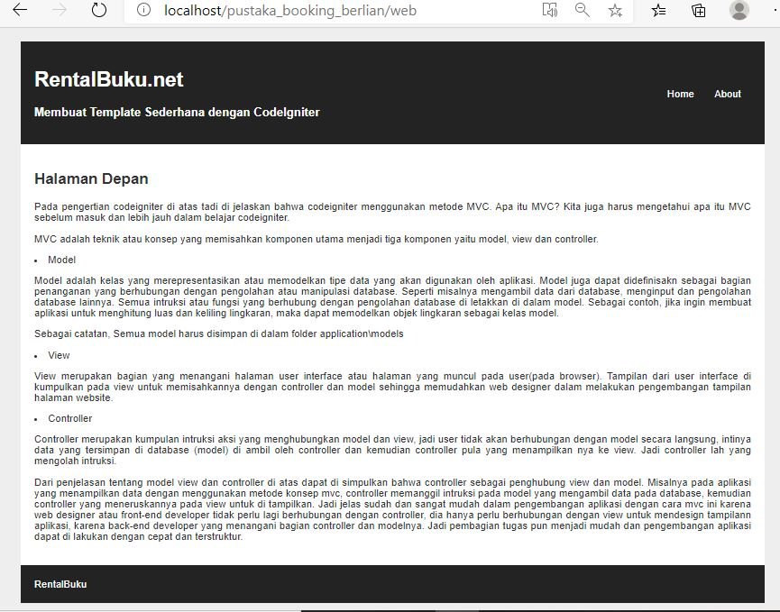

v_about.php

